## FPT ACADEMY INTERNATIONAL FPT – APTECH COMPUTER EDUCATION



**MYTiles**

|  |  |  |  |
| --- | --- | --- | --- |
| **Center Name** | | FPT – Aptech – HCMC  Address: 590 Cach Mang Thang Tam, District 3, Ho Chi Minh City | |
| **Instructor** |  | Ms. Le Mong Thuy |  |
| **Class** |  | T1.2309.M1 |  |
| **Group** |  | 1 |  |
| **Group members** | | **Name** | **Student ID** |
|  |  | Le Huu Xuan Binh | Student1518659 |
|  |  | Nguyen Quoc Huy | Student1518650 |
|  |  | Doan Thanh Tung | Student1518654 |
| **Duration** | Start date | 23th December 2023 |  |
| End date | 23th January 2024 |  |

### This is to certify that Mr. and Ms.:

Le Huu Xuan Binh

Nguyen Quoc Huy

Doan Thanh Tung

### has successfully designed & developed

eProject: MYTiles website

### Submitted by:

Le Huu Xuan Binh

**Date of issue:**

**Authorized Signature:**

## TABLE OF CONTENT

FPT – APTECH COMPUTER EDUCATION 1

TABLE OF CONTENT 2

ACKNOWLEGMENT 3

SYNOSIS 3

PROBLEM DEFINITION 3

CUSTOMER'S REQUIREMENTS SPECIFICATIONS (CRS) 5

Business/Project Objective: 5

Hardware/ Software Requirements 6

SCOPE OF THE WORK (IN BRIEF) 7

ARCHITECTURE AND DESIGN OF THE SYSTEM 8

DIAGRAM OF THE WEBSITE 9

TASK SHEET REVIEW 1 10

SITE MAP 11

MOCK OF THE WEB SITE 12

1. Home 12
2. All Tile 14
3. Type of Tile 15
4. Expert corner 16

TASK SHEET REVIEW 2 29

## ACKNOWLEGMENT

On behalf of team members. I would like to thank everyone who supported my team to successfully complete this eProject report. Especially, our teacher, she has supported us a lot since we started studying at FPT Aptech. With this eProject, she guided us very meticulously, enthusiastically and strictly. With her guidance, we were able to successfully complete this project. Besides, I also want to thank all the team members, each of whom worked hard to complete the eProject in earnest during the month of working together. Finally, our group would like to say thank you to my classmates and family for sharing and creating for the group the best environment to focus on the project, motivating the members to achieve their goals.

## SYNOSIS

The goal of the eProject is that we need to create a website that meets all the requirements of the client, Cera’s. Cera’s is an organization selling entire range of ceramic tiles and related products. They provide variety of tiles suitable for each and every kind of construction starting from office to home and etc. They always satisfy customers with professional staff with many years of experience. The main goal of this website is to reach customers who need the best quality ceramic tile products for their home or company. In addition, the products have discounts and promotions for customers, especially the company also supports the direct installation of their products. Customer satisfaction is always the top goal of Cera’s.

## PROBLEM DEFINITION

The Web site is to be created based on the following requirements.

1) The Home Page should be created making use of Sections with a suitable logo, the header section can be added which will show images of various furnishing products.

2) The site must contain the links to navigate through any category for the information.

3) The site should display a menu which will contain following categories of tiles

• Wall tiles

o Bathroom wall tiles

o Kitchen wall tiles

o Outdoor wall tiles

o Living room

o Bedroom

o Commercial spaces tiles

• Floor tiles

o Bathroom floor tiles

o Kitchen floor tiles

o Outdoor floor tiles

o Living room

o Bedroom

o Commercial spaces tiles

• Special tiles

o Germ free: a selected range of Tiles and Kitchen Countertops with the Anti-Bacterial and Anti-Viral Advantage

o Tac : Tactile are unique non-fade, non-slip ground surface indicators (vitrified tiles). These indicators provide cues, which combined with other environmental information, assist visually challenged people with their orientation.

o Anti static : the industrial tiling solution that has looked into a very niche but highly important areas, which are sensitive to static electricity.

o Cool roof : tiles, a range of unique tiles that keeps the harsh rays of the sun off your building. Recommended laying for terrace, balcony, and courtyard and beat the heat inside your home and save energy.

4) There should be e-catalogue available for download which should include complete details of entire range of tiles like:

I. Glazed vitrified tiles

II. Ceramic tiles

III. Polished vitrified tiles

5) Each menu option mentioned above should have sub categories according to the range of products available in that category.

6) A brief summary of features of the products should be displayed on the Web Page along with the picture but detailed Features should be stored in Individual Word documents which can be downloaded or viewed by the User who wishes to see the same.

7) The user should also be able to compare the various products of different types of tiles

8) There should also be a section “Expert corner” where blogs, tile guide, educational videos, tiles calculator etc. should be available as ready reference for buyers.

9) There should be a “Contact Us” page which will have the Address of the Company which should be displayed using GeoLocation API (eg. GoogleMaps) and the email address which when clicked will invoke the local mail client from where they can send an email.

## CUSTOMER'S REQUIREMENTS SPECIFICATIONS (CRS)

### Client: Cera’s

### Business/Project Objective:

Tiles are usually thin, square or rectangular coverings manufactured from hard-wearing material such as ceramic, stone, metal, baked clay, or even glass.

Tiles are often used to form wall and floor coverings, and can range from simple square tiles to complex or mosaics.

Essentially, there are three main types of tile: Wall tiles, Floor tiles, and Special tiles. Within each type, there are a lot of design and size. Seeing examples of these tiles can help you choose the best one for your home and get inspired to create something amazing.

Here we are aiming to design a website “MYTiles” which will provide an easy way to review and provide the basic other details about the tile.

**Input to the system:**

* Searching tile images based on type and name.
* User’s view on tile images.
* Pop up information based on user’s interact.
* User’s information in contact form.
* User’s location.
* Links to user’s social networking sites.

**Output from the system:**

* Searching results based on: name, and type of tile.
* Image information by view.
* User’s location.
* The location of the foundations on the Contact page.

**Process**:

* Display pop up information based on user’s interact.
* Filter tile images based on name searching, and type of tile.
* Display image information by view.
* Display user’s location.

**Expected delivery date:** 23-January-2024.

**List of deliverables:**

* Document Word, PDF.
* User Guide.

### Hardware/ Software Requirements:

* **For developer Hardware**
  + A minimum computer system that will help you access all the tools in the courses is a

Pentium 166 or better.

* + 64 Megabytes of RAM or better.

### Software [Either or Combination as per Course/Sem]

* + Notepad/HTML editor/CoffeeCup
  + Angular / Angular JS / React / BootStrap
  + Dreamweaver / Figma
  + MS IE / Chrome / FireFox / Netscape /MS Edge

### For web users Hardware

* + A minimum computer system that will help you access all the tools in the courses is a

Pentium 166 or better.

* + 64 Megabytes of RAM or better.

### Software [Either or Combination as per Course/Sem]

* + Notepad/HTML editor/CoffeeCup
  + Angular / Angular JS / React / BootStrap
  + Dreamweaver / Figma
  + MS IE / Chrome / FireFox / Netscape /MS Edge

## SCOPE OF THE WORK (IN BRIEF)

After a long and detailed discussion, our group has decided to create a website contain the following webpages:

1. ***Homepage:*** Displays the summary information about tiles and the types of its go with illustrations.
2. ***Tile:*** Display detailed information and images of all products.
3. ***Tile(Type of Tiles):*** Display detailed information and images of specific products. Also we can compare products with each other
4. ***Expert Corner:*** Q&A, sharing of expert about how to choose and install tile that match customers ‘s purpose.

## ARCHITECTURE AND DESIGN OF THE SYSTEM

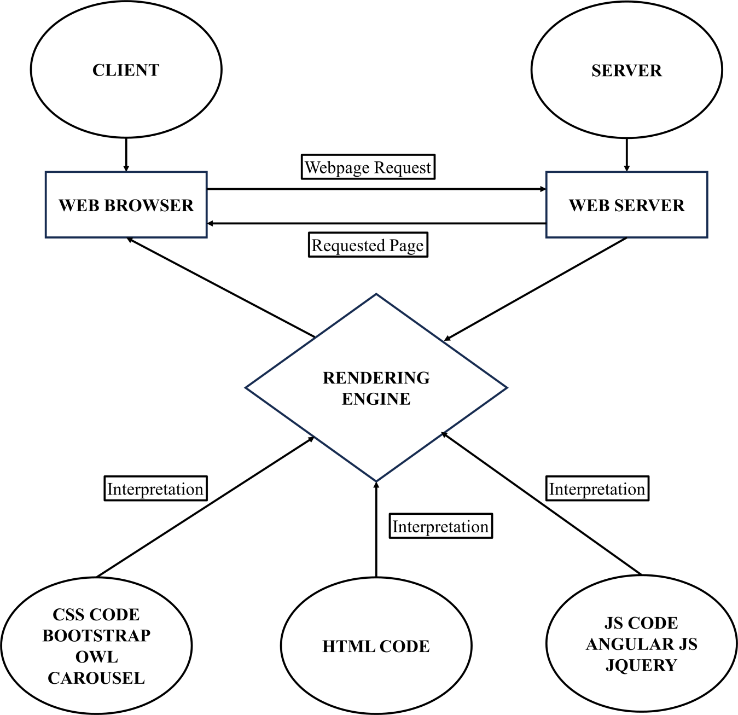

## DIAGRAM OF THE WEBSITE

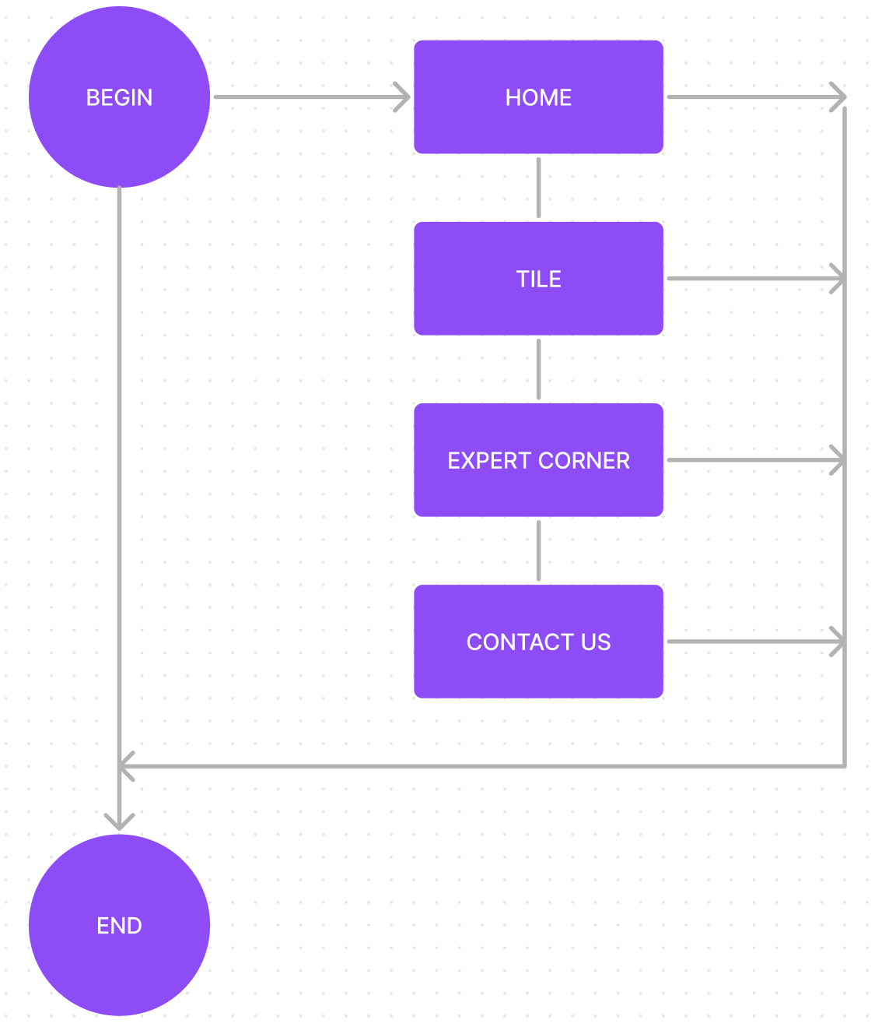

# TASK SHEET REVIEW 1

|  |  |  |  |  |  |  |  |
| --- | --- | --- | --- | --- | --- | --- | --- |
| **Project Ref. No.:**  **eP/Advertisement Portal Management**  **System/01** | | **Project Title:** | **Activity Plan Prepared By:** | **Date of Preparation of Activity Plan:** | | | |
| **Sr.**  **No.** | **Task** | **Actual Start Date** | **Actual Days** | **Team Mate Names** | **Status** |
| 1 | Problem Statement | MYTiles | Binh | 23-Dec-23 | 1 | Binh | Completed |
| 2 | Analysis of Quick  Calligraphy requirements about the website | 23-Dec-23 | 1 | Tung | Completed |
| 3 | The scope of the work (in brief) | 23-Dec-23 | 1 | Binh | Completed |
| 4 | Architecture and design of the system | 23-Dec-23 | 1 | Huy | Completed |
| 5 | Diagram of the website | 23-Dec-23 | 1 | Huy | Completed |
| 6 | Task Sheet | 23-Dec-23 | 1 | Tung | Completed |

|  |  |
| --- | --- |
| **Date:** | |
| Signature of Instructor:  **Ms. Le Mong Thuy** | Signature of Team Leader:  **Le Huu Xuan Binh** |

# SITE MAP

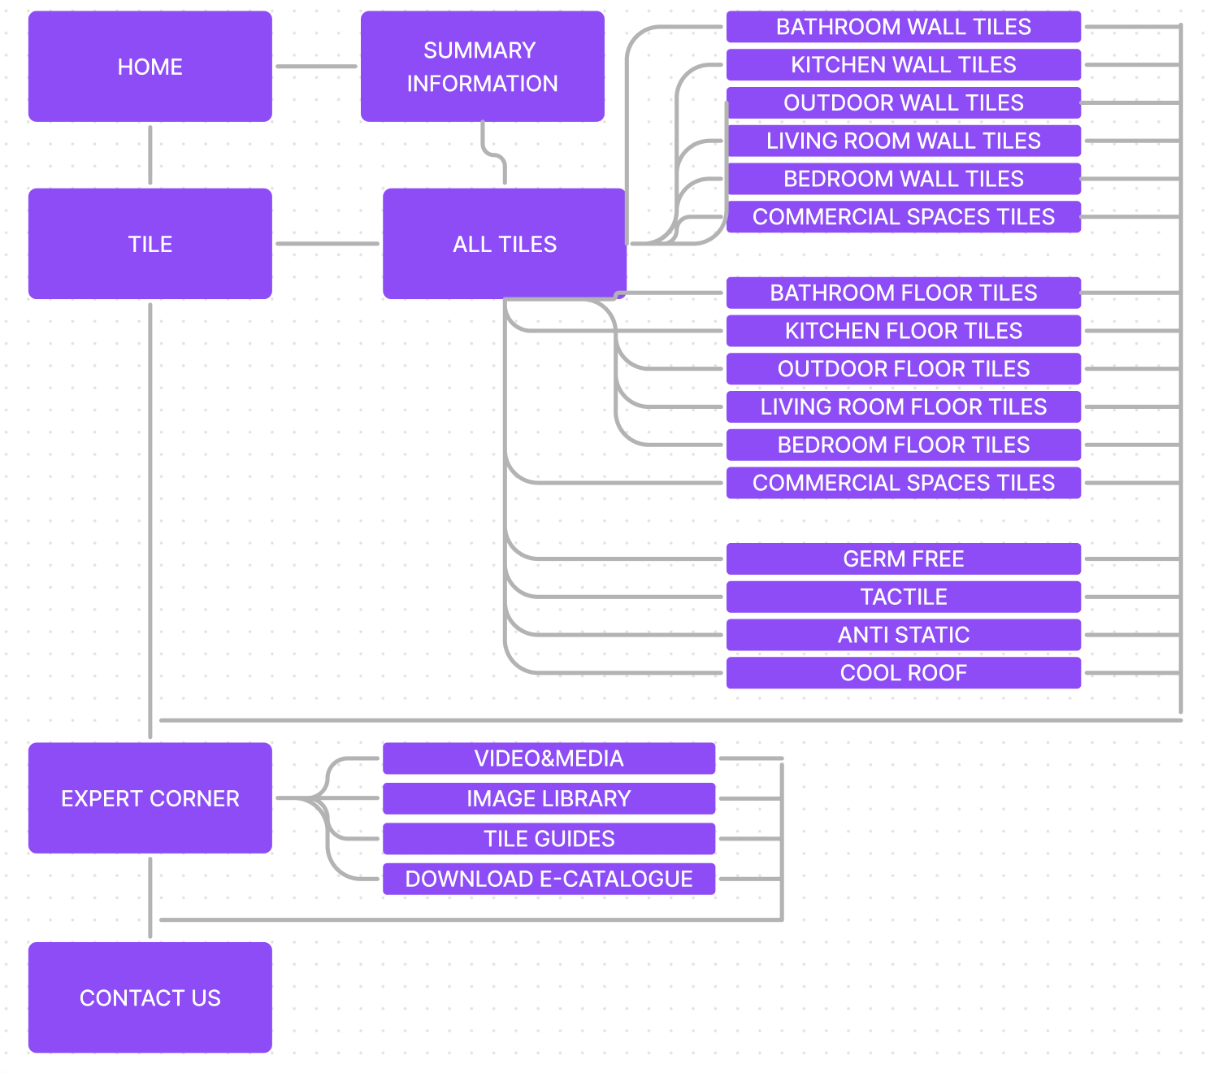

## MOCK OF THE WEB SITE

### Home

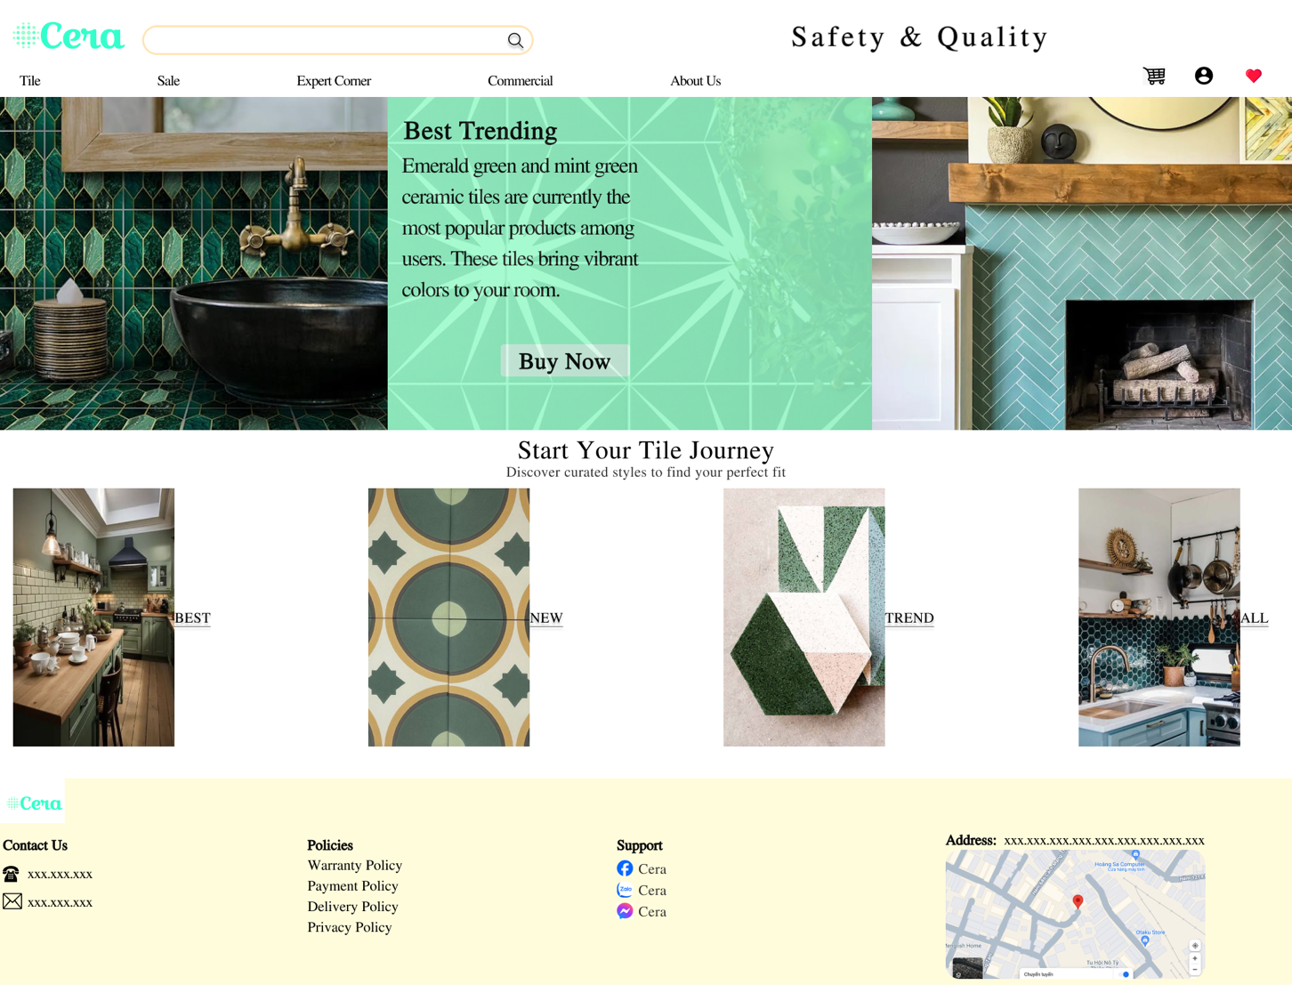

**Figure 1: Homepage – part 1**

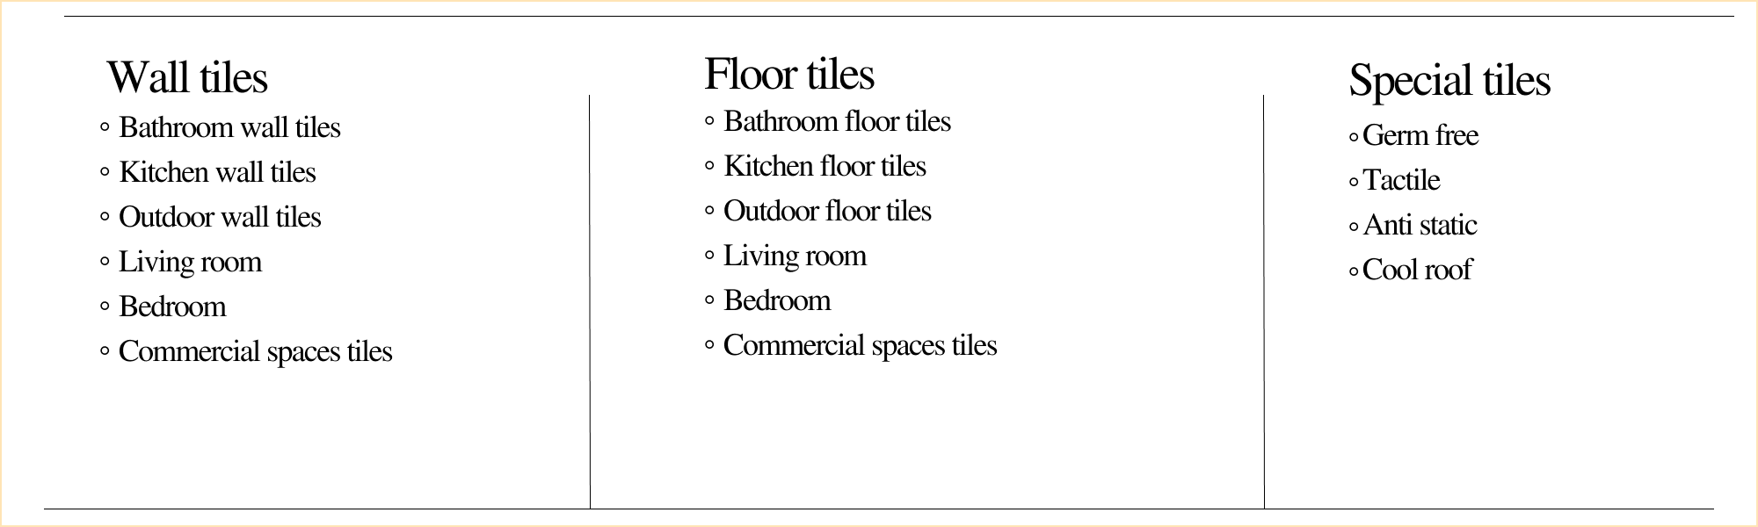

**Figure 2: Homepage – part 2**

(Tile menu)

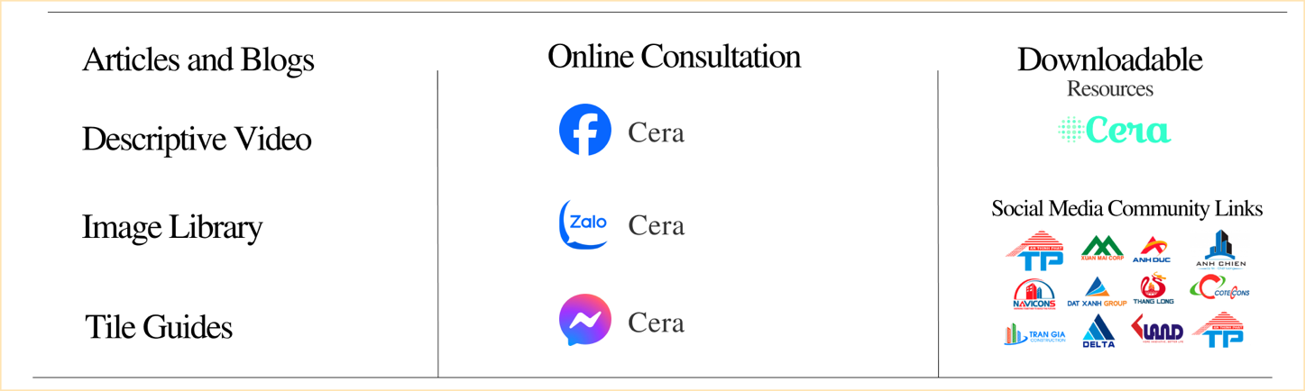

**Figure 3: Homepage – part 3** (Expert corner menu)

### Tile

**Figure 4: Tile page**

### Tile( Type of Tile)

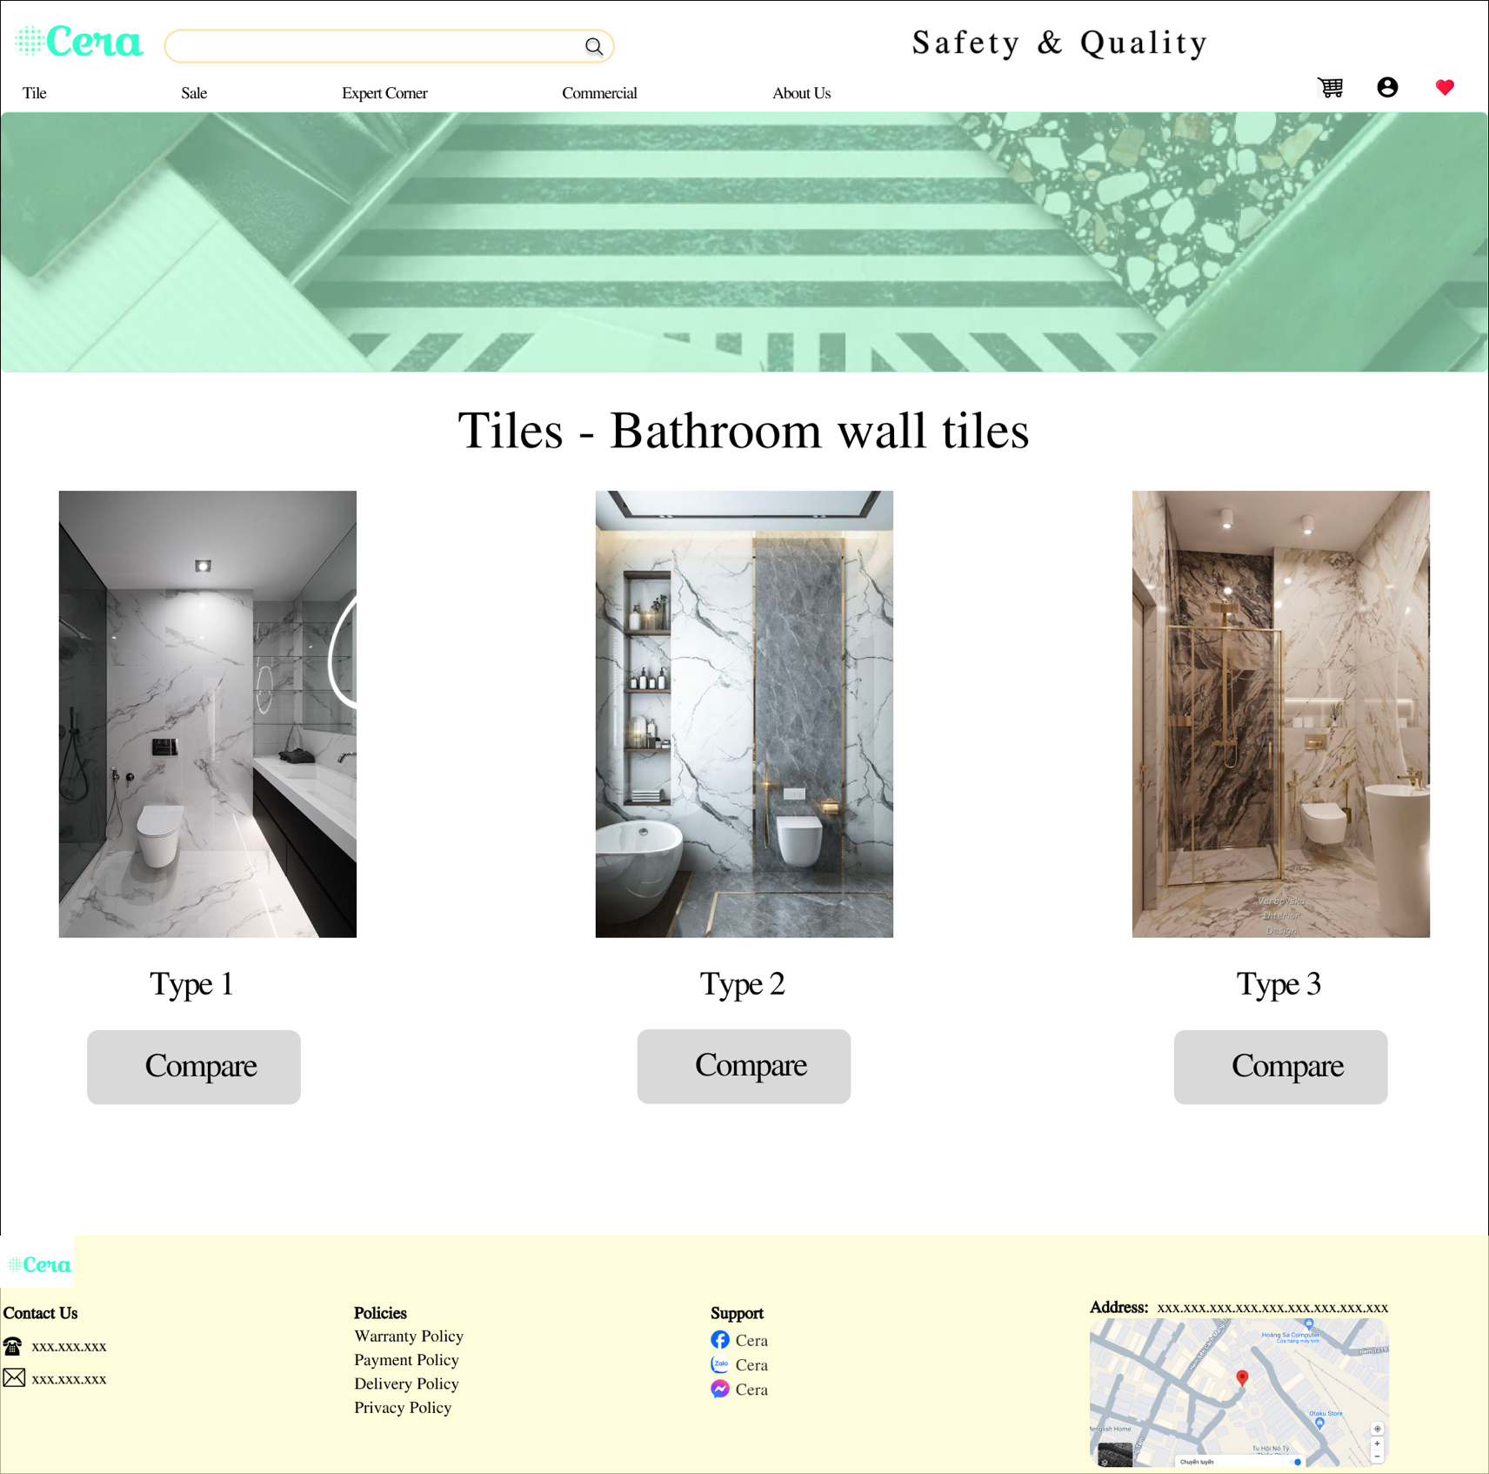

**Figure 5: Type of Tile page**

### Expert corner

### 

**Figure 6: Expert corner page**

# TASK SHEET REVIEW 2

|  |  |  |  |  |  |  |  |
| --- | --- | --- | --- | --- | --- | --- | --- |
| **Project Ref. No.:**  **eP/Advertisement Portal Management**  **System/01** | | **Project Title:** | **Activity Plan Prepared By:** | **Date of Preparation of Activity Plan:** | | | |
| **Sr.**  **No.** | **Task** | **Actual Start Date** | **Actual Days** | **Team Mate Names** | **Status** |
| 1 | Site Map | MYTiles | Binh | 28-Dec-23 | 5 | Binh | Completed |
| 2 | Mock of the website | 28-Dec-23 | 5 | Huy | Completed |
| 3 | Task sheet | 28-Dec-23 | 5 | Tung | Completed |

|  |  |
| --- | --- |
| **Date:** | |
| Signature of Instructor:  **Ms. Le Mong Thuy** | Signature of Team Leader:  **Le Huu Xuan Binh** |

# WEBSITE DESCRIPTION

1. **Homepage**
2. Description

Home page displays following information:

- Slide show programs, services and product promotions

- Feature product.

- Some information about the website.

1. 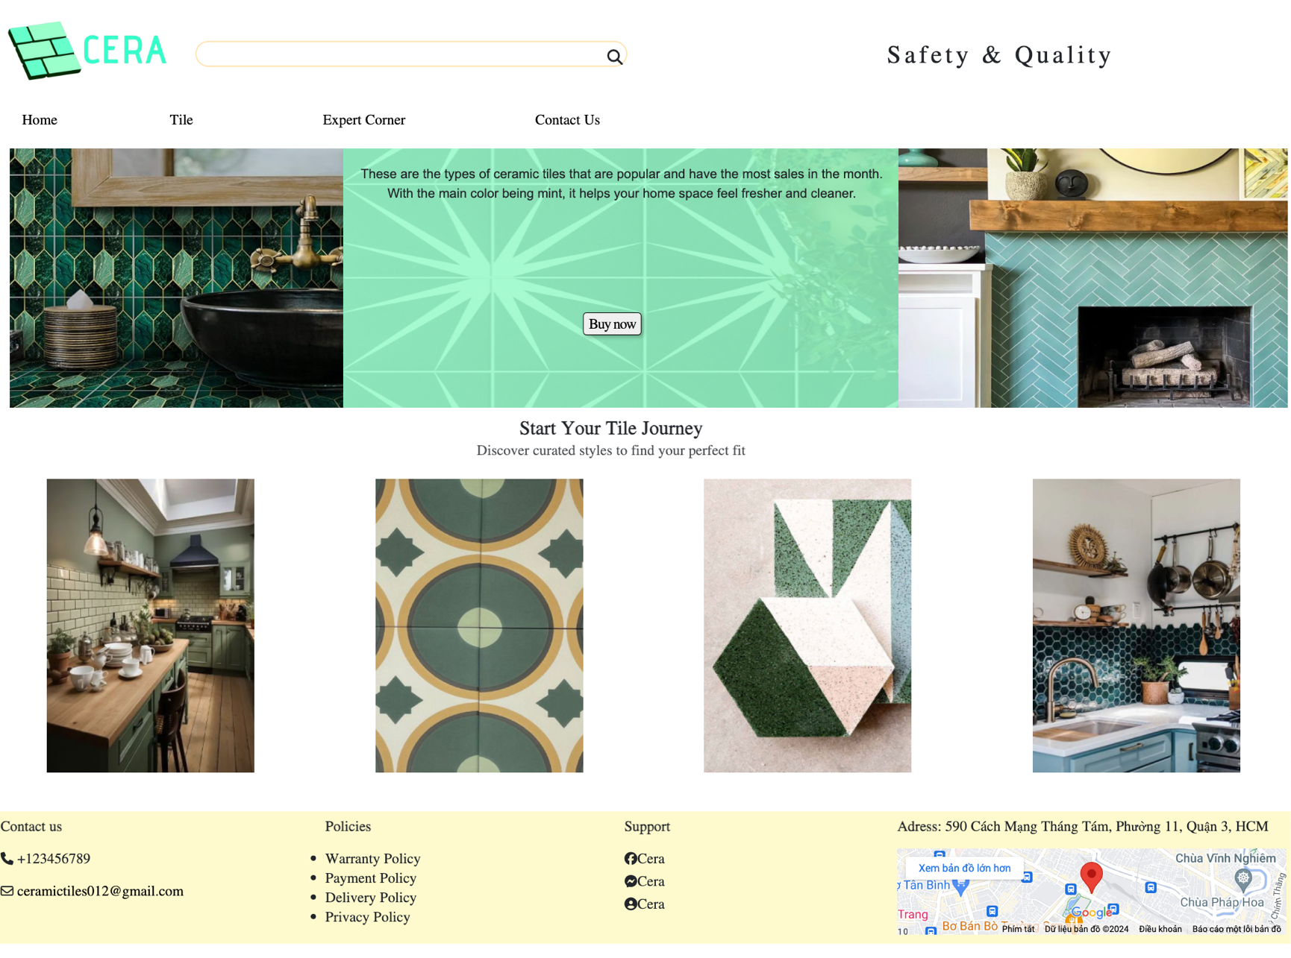Screen shot
2. **Tile**
3. Description

This tile page displays following information:

- Link to other small tile pages.

- Products can be compared with products of the same category

1. Screen shot

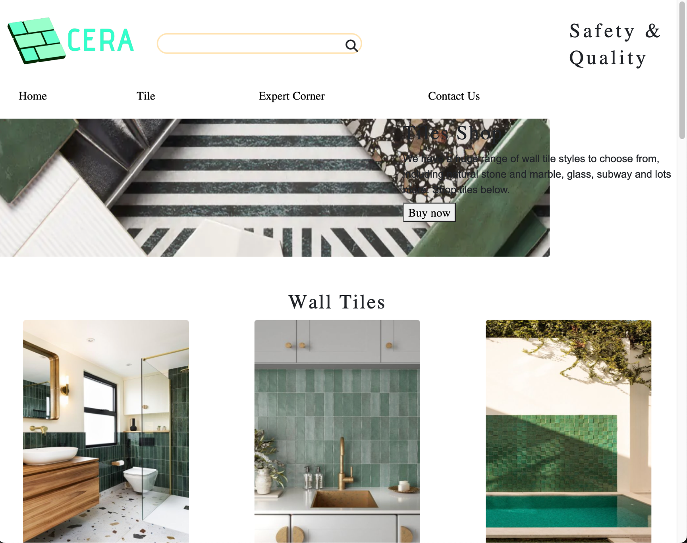

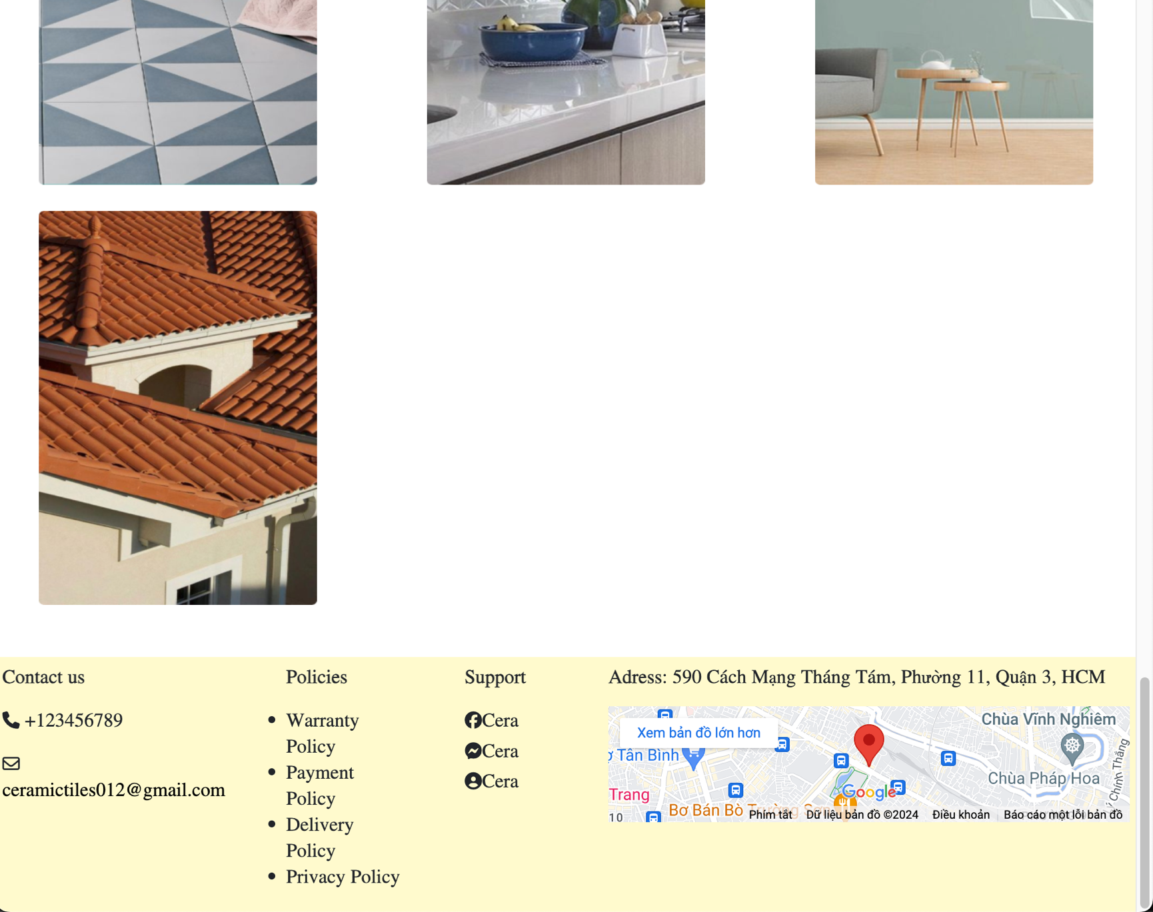

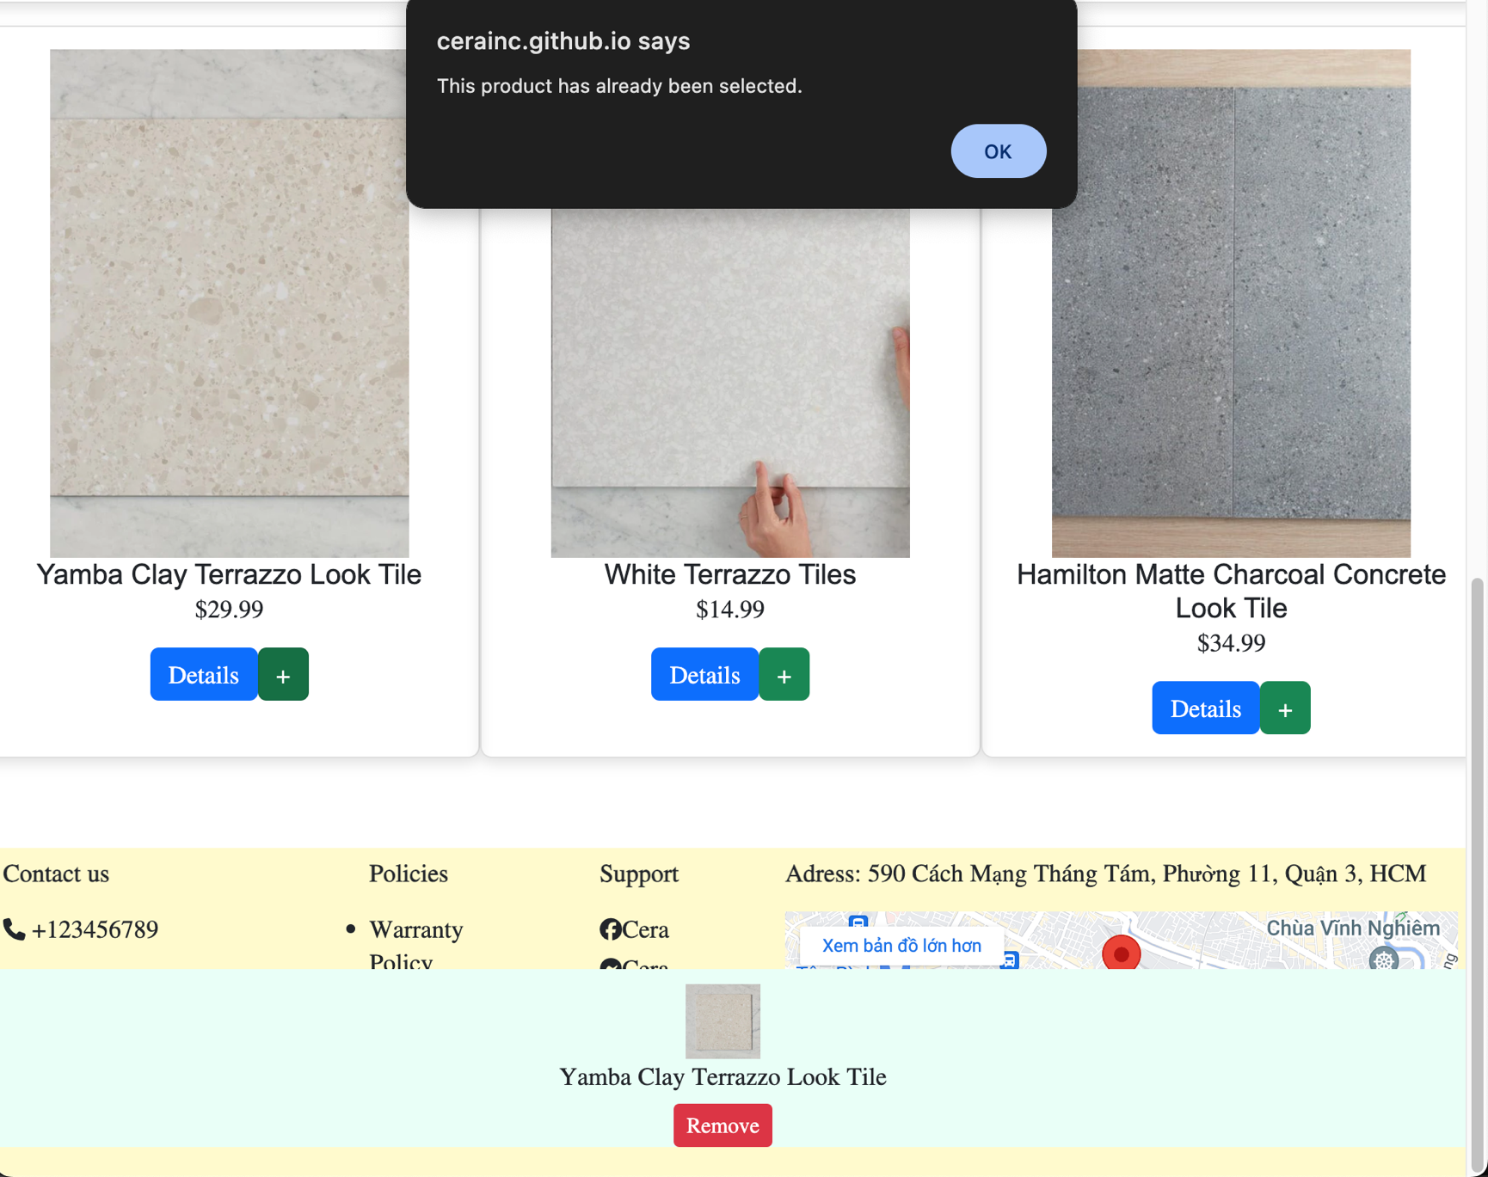

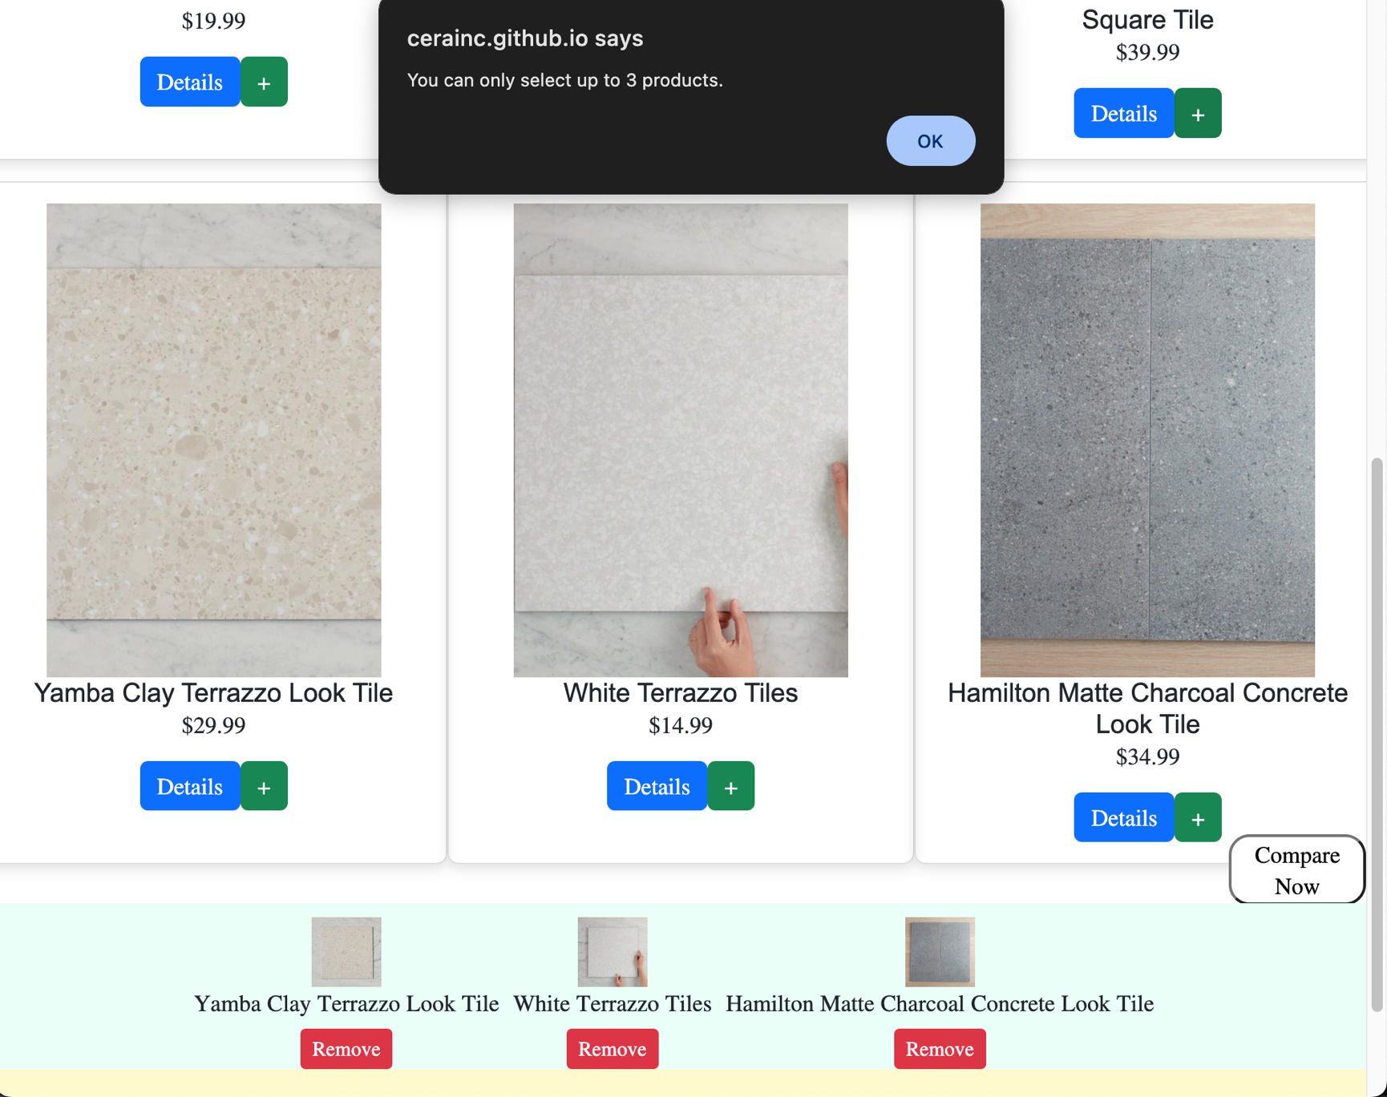

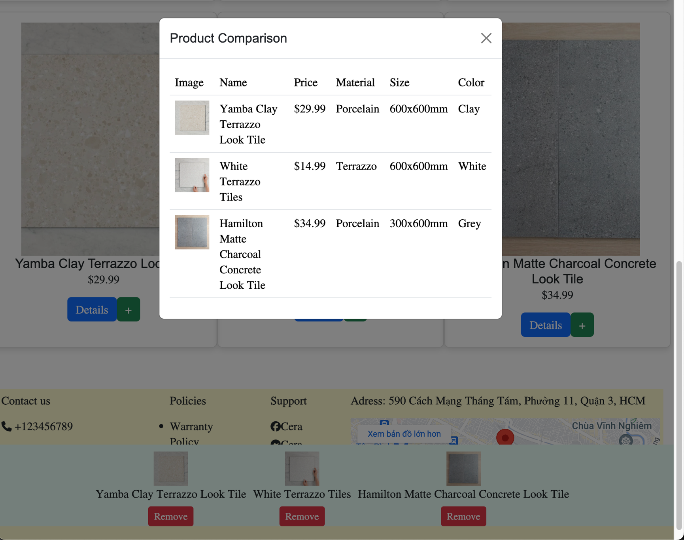

1. **Expert corner**
2. Description

The page contain 3 small page:

- Tile Guides: Q&A about customer questions

- Descriptive Video: contain tile guides video, inspiration of tile install design

- Image Library: contain product image also 3 employees

1. Screen shot